Midweek Worship in Lent
March 20, 2024

Protected in Love

St. Matthew’s Lutheran Church
Evangelical Lutheran Church in America

12351 All Saints Place

Woodbridge, VA 22192

Phone (703) 494-3090

E-Mail: stmatthews@stmatthewsva.org
www.stmatthewsva.org

Weekly Sunday Worship......…... 10:00AM
Sunday School……….……….11:30 AM

Week Five – Protected in Love

Evening Prayer
Vespers

Opening
The assembly stands. A dialogue accompanies the procession. The assembly responds to the leader.
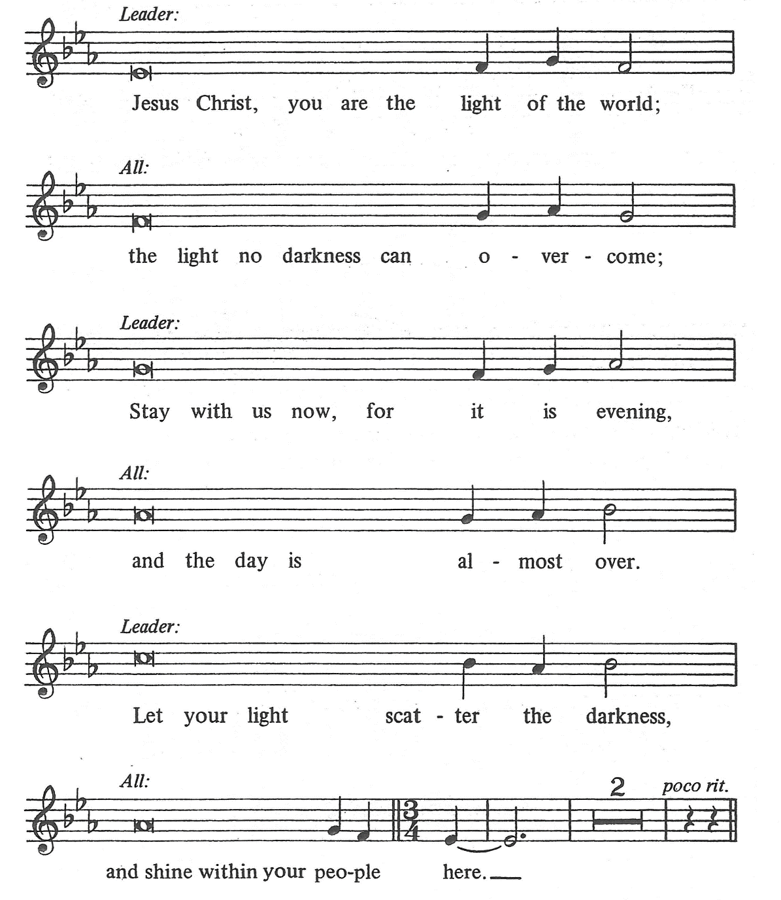

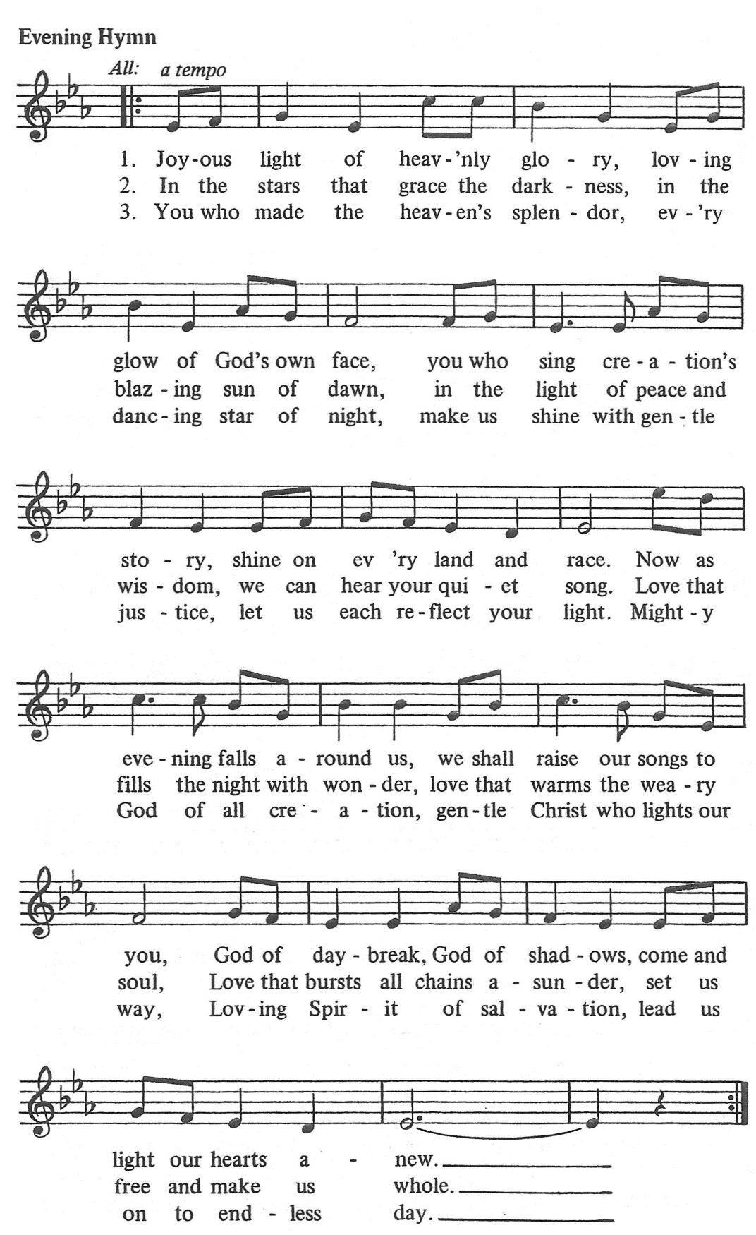

The assembly sits.

First Reading Psalm 91

A: A reading from Psalms.

You who live in the shelter of the Most High, who abide in the shadow of the Almighty, will say to the LORD, "My refuge and my fortress; my God, in whom I trust." For he will deliver you from the snare of the fowler and from the deadly pestilence; he will cover you with his pinions, and under his wings you will find refuge; his faithfulness is a shield and buckler. You will not fear the terror of the night, or the arrow that flies by day, or the pestilence that stalks in darkness, or the destruction that wastes at noonday. A thousand may fall at your side, ten thousand at your right hand, but it will not come near you. You will only look with your eyes and see the punishment of the wicked. Because you have made the LORD your refuge, the Most High your dwelling place, no evil shall befall you, no scourge come near your tent. For he will command his angels concerning you to guard you in all your ways. On their hands they will bear you up, so that you will not dash your foot against a stone. You will tread on the lion and the adder, the young lion and the serpent you will trample under foot. Those who love me, I will deliver; I will protect those who know my name. When they call to me, I will answer them; I will be with them in trouble, I will rescue them and honor them. With long life I will satisfy them, and show them my salvation.

A: The word of the Lord. C: Thanks be to God.
The Psalm Psalm 141

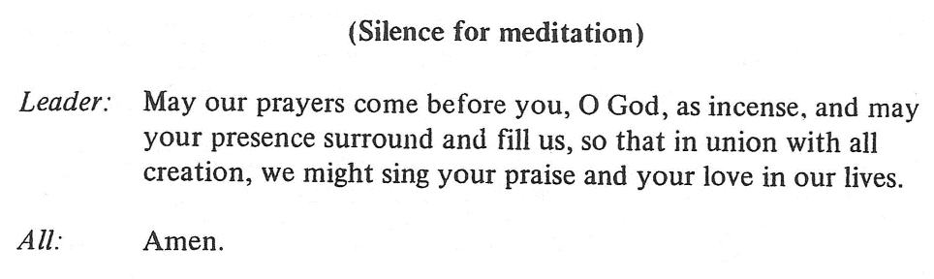

The assembly stands.

L: Just as Moses lifted up the serpent in the wilderness, so must the Son of Man be
lifted up.
C: that whoever believes in him may have eternal love.
L: God reached down in love to give us his Son.
C: So we reach out in love this Lenten season.
L: With arms extended on the cross, Jesus embraced the whole world with his
matchless love.
C: So we embrace those around us with the Good News that we are dearly
loved by our God with a love that never dies.
L: We lift up our lives to the Lord this Lent and always
C: that we may pray to him, give of ourselves and freely serve in a loving
manner all our days.

Holy Gospel John 17:10-24

P: The Gospel according to St. John. C: Glory to you, O Lord.

¹⁰All mine are yours, and yours are mine; and I have been glorified in them. ¹¹And now I am no longer in the world, but they are in the world, and I am coming to you. Holy Father, protect them in your name that you have given me, so that they may be one, as we are one. ¹²While I was with them, I protected them in your name that you have given me. I guarded them, and not one of them was lost except the one destined to be lost, so that the scripture might be fulfilled. ¹³But now I am coming to you, and I speak these things in the world so that they may have my joy made complete in themselves. ¹⁴I have given them your word, and the world has hated them because they do not belong to the world, just as I do not belong to the world. ¹⁵I am not asking you to take them out of the world, but I ask you to protect them from the evil one. ¹⁶They do not belong to the world, just as I do not belong to the world. ¹⁷Sanctify them in the truth; your word is truth. ¹⁸As you have sent me into the world, so I have sent them into the world. ¹⁹And for their sakes I sanctify myself, so that they also may be sanctified in truth. ²⁰I ask not only on behalf of these, but also on behalf of those who will believe in me through their word, ²¹that they may all be one. As you, Father, are in me and I am in you, may they also be in us, so that the world may believe that you have sent me. ²²The glory that you have given me I have given them, so that they may be one, as we are one, ²³I in them and you in me, that they may become completely one, so that the world may know that you have sent me and have loved them even as you have loved me. ²⁴Father, I desire that those also, whom you have given me, may be with me where I am, to see my glory, which you have given me because you loved me before the foundation of the world.

P: The Gospel of the Lord. C: Praise to you, O Christ.

The assembly sits.

Meditation Protected in Love Pastor Stephen Bohannon

The assembly stands.

Hymn Lord, Keep Us Steadfast in Your Word

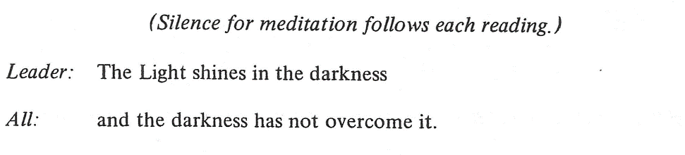
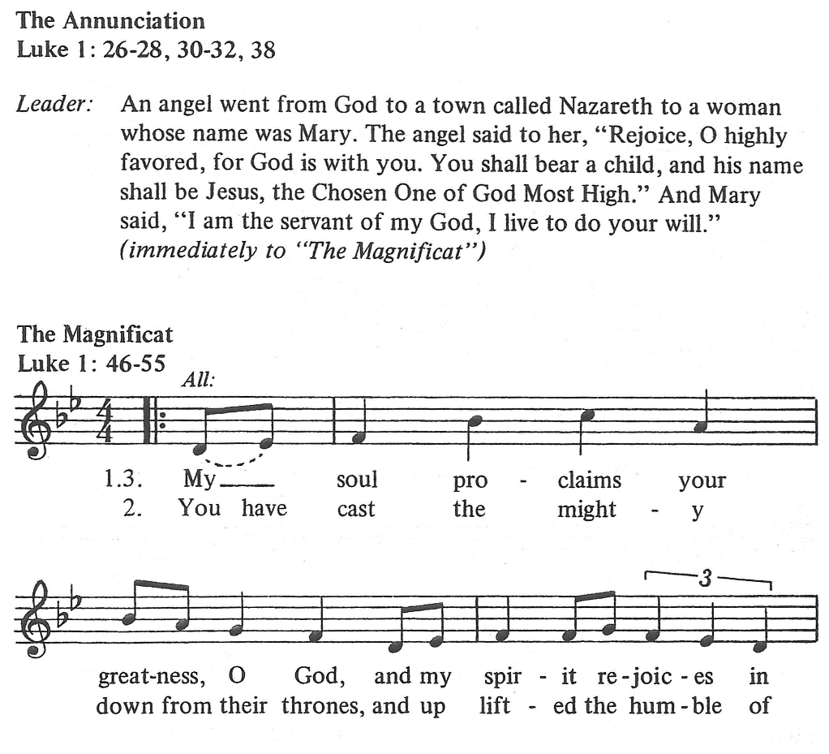

The assembly sits.

Lenten offerings are designated to fulfill mission directives not contained within our congregation’s spending plan. Our special Lenten offerings, will be given to Caroline Furnace Lutheran Camp and Retreat Center and our partnerships with the Lutheran Church in Namibia. Caroline Furnace is home to parish retreats, Confirmation Camp, and summer camp experiences for youth from across three synods of the ELCA. Located in Fort Valley, just across the mountain from Luray Caverns, Caroline Furnace is one of many historic sites in the area where pig iron was mined and refined in the 1800’s. The 300 acre camp provides a rustic retreat center, surrounded by nature in the mountains of Virginia and has served as a place for youth and adults to have unforgettable faith experiences for over 60 years.

St. Matthew’s has long been a pillar of support for the Metro D.C. Synod’s relationship with sister synods in other parts of the world. We have unique opportunities in Namibia through our past support of the Lutheran Church there, especially as it supports education, and through our relationship with Pastor Nahuma Ambole. Together with other congregations in the Metro D.C. and Virginia Synods we are providing financial support for Pastor Ambole to finish his seminary education. He will join us this summer while he is here serving at Caroline Furnace!

The Lutheran churches in Namibia is made up of 3 different denominations: the Evangelical Lutheran Church in Namibia (ELCIN), the Evangelical Lutheran Church in the Republic of Namibia (ELCRN), and the German Evangelical Lutheran Church-ELCIN (GELC-ELCIN)

The assembly stands.

Offertory ELW 884
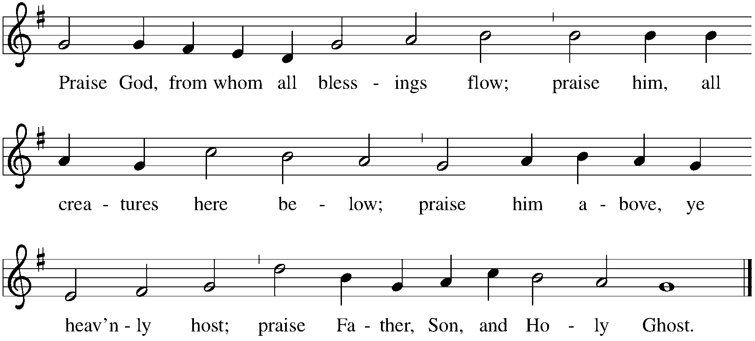

Offertory Prayer

A: Let us pray. Blessed are you, O God, maker of all things, through your goodness you have blessed us with these gifts: ourselves, our time, and our possessions. Use us, and what we have gathered, in feeding the world with your love, through the one who gave himself for us, Jesus Christ, our Savior and Lord. C: Amen.

The assembly kneels or sits.

The Prayers of the Church

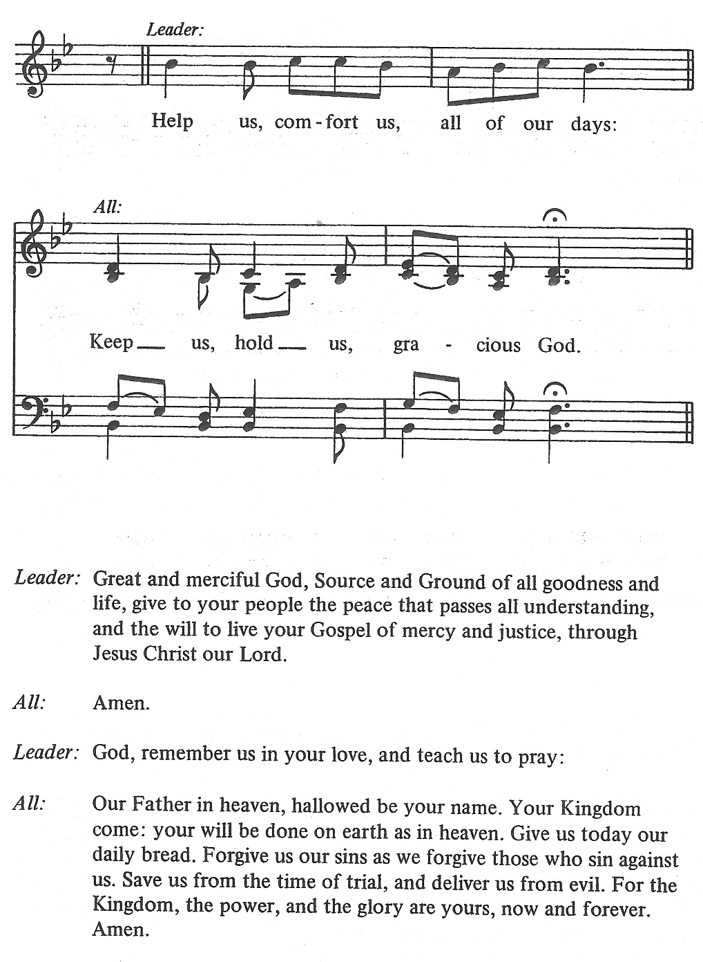

The assembly stands.
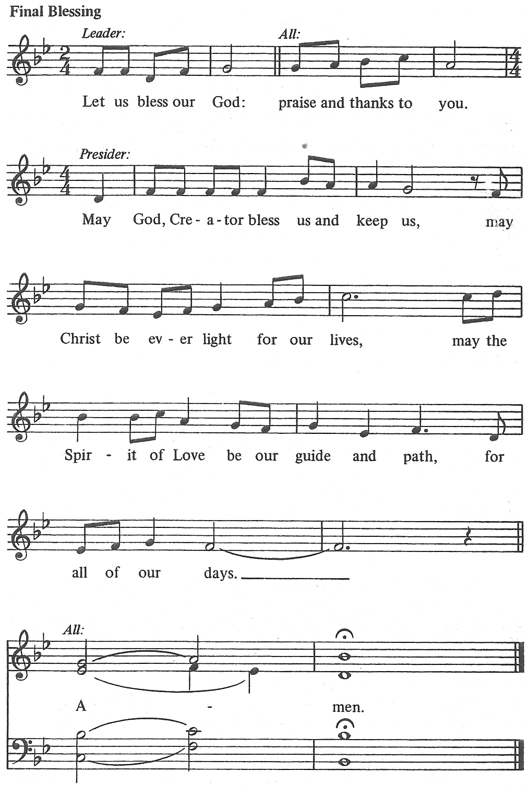

Leader: Go in Peace. Serve the Lord.
All: Thanks be to God.

